Pre-Treatment Evaluation Form

Name: Date:

Medical History:

Dates of any surgeries including cosmetic:

Current Medications:

Facial Medications:

Drug, Contact, Food Allergies:

Pregnant or planning to be pregnant:

Have you received a skin exam with a dermatologist in the last year? Yes No

Do you smoke? Yes No
Do you drink? Yes
No

Any previous peels, microdermabrasion, laser treatments? Yes
No
Last Treatment

Wax, pluck, shave, bleach, trim, electrolysis for unwanted hair? Area Last Exposure

Have you ever taken Accutane? Yes
No
If so, when

Any history of herpes, hives, cold sores, fever blisters, or shingles? Yes
No
Last Exposure

Any history of keloids (abnormal scarring) Yes No

Do you suntan? Yes
No Do you use self-tanning lotions? Yes
No

Do you use sunscreen every day? Yes No What SPF
Have you ever had: Botox Collagen injections Date

Perm Make Up Tattoo: Yes No Location/Site:

What is your current skin care regimen including cleansers, toners, moisturizers, scrubs, facial masks, etc.?

SKIN TYPE:
Normal

Oily

Combination

Dry

Sensitive

Rough

What areas would you like to improve upon?

Office use only:
Benefits of procedure discussed: Yes No Risks reviewed: Yes No

Contraindications reviewed: Yes No Probability of success: Yes No

Patient going to proceed with: LHR IPL VBeam Isolaz MDA Peels Sublative C+B HF Vivace______

Services Suggested:

Products Suggested: _ Signature of consultant:

COSMETIC PATIENT REGISTRATION

(Office Use) Patient Account #

Please PRINT Clearly Today’s Date:

PATIENT:

How did you hear about us? □ Yellow Pages □ Physician □ Friend

The News Journal □ Delaware Today □ Other

Title: □ Mr. □ Ms. □ Family

Name: (Last) (First) (Middle)

Address:

(Street) (City) (State)
(Zip)

DOB: Gender: □ Male □ Female E-Mail:

Status: □ Single □Married □ Other

Phone:
Phone:
Phone:

(Home) (Work)
(Cell/Mobile)

Patient’s Occupation:

Person to Contact in Case of Emergency:

Phone:

S:\Forms\Cosmetic Patient Registration.docx 3/23/17

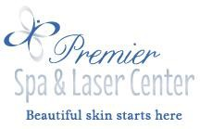Thank you for choosing PREMIER SPA & LASER CENTER for your aesthetic needs.
Please be advised that our services are elective cosmetic procedures, the care provided at Premier Spa & Laser Center is not covered by any medical insurance programs and we do not participate in any such plans. Payment is required at the time of your treatment. For specially packaged treatments, payment for the entire package is due at the time of the first scheduled treatment.
Please read and sign our financial and etiquette policy below to verify your receipt and understanding of this information.

- For the comfort of all our guests, please reduce or mute the volume on your cell phones, laptops, and pagers.
- Please refrain from inappropriate language or actions. If this does occur your aesthetic provider may terminate your service, without a refund.
- For safety reasons, the maximum occupancy of each spa room is two people. Anyone accompanying you to your spa visit is welcomed to wait in the waiting room.
- Children under 12 may not be left unattended; you may need to reschedule your appointment should your children come with you to the spa.
- We provide a number of payment options which may be used individually or combined according to your desires. Cash, check, Visa, and MasterCard are accepted.
- Returned checks are subject to a $30.00 service charge.
- We value your business and understand that sometimes schedule adjustments are necessary; therefore, we respectfully request at least 24 hours’ notice for cancellations.
- Our appointments are confirmed 48 hours in advance because we know how easy it is to forget an appointment you booked months ago. Since the services are reserved for you personally, a cancellation fee may apply.
- NO SHOWS may be charged 100% of the reserved service amount.
- Clients arriving ten minutes after their scheduled appointment time will be considered late for their appointment, and their appointment may be rescheduled as a result, allowing the provider to take their next scheduled appointment on time.
- Every effort is made to accommodate your request to see specific providers but we cannot guarantee that you see the same provider for all treatments. We will inform you of these changes prior to treatment.
- Clients who no show on more than one occasion may be required to pay in advance for any services booked.
- For all Coolsculpting treatments, a 10% deposit is required at the time of scheduling the appointment. This deposit may be forfeited, if a cancellation less than 24 hours occurs or the appointment is missed.
- Any other services that require more than 60 minutes will be charged a $100 deposit in order to hold the appointment. The deposit will be applied once services are rendered. This deposit may be forfeited, if a cancellation less than 24 hours occurs or the appointment is missed
- Skin care product purchases can be returned within 30 days of purchase, ONLY if they are unopened and unused. Latisse, Renova, Retin A and Hydroquinone products cannot be returned. All Clarisonic product returns or problems must be done through L’Oreal/Clarisonic. We can provide you the necessary receipt to assist with your return. A refund by Premier Spa & Laser Center may not be provided in the same form of initial payment(s). All refunds will be provided by a check in the mail within 2-3 weeks of receipt of return. If you do not wish a check refund a credit can be left on your account for future service(s) and/or purchase(s) within the spa.
These policies are subject to change without notice. If you have any questions or need assistance with any financial matters relating to your treatment, please contact our Aesthetic Associates for help.
X DATE: MRN: PATIENT, GUARANTOR, OR PERSONAL REPRESENTATIVE’S SIGNATURE
The patient/guarantor has the responsibility to inform PSLC if the patient’s contact information changes, i.e. phone number, address, and email. Your signature on this page signifies that you acknowledge and accept the above information.

TREATMENT CONSIDERATIONS FORM

The CoolSculpting® procedure is a non-invasive procedure that is intended to change the appearance of the treatment area by delivering controlled cooling at the surface of the skin to break down fat cells that are just beneath the skin. This procedure is not a treatment for obesity or a weight-loss solution. The CoolSculpting procedure does not replace traditional methods such as diet, exercise or liposuction. Initial:

Clinical studies of a treatment site have shown that the CoolSculpting procedure can break down fat cells to change the appearance of visibly localized bulges of fat that is just beneath the skin on the abdomen, thighs, flanks and submental area. The submental area is the area under the chin. Following the procedure, the treated fat cells are naturally processed by the body. Visible results can vary from person to person. Initial:

WHAT YOU CAN EXPECT:

Temporary Sensations / Symptoms:
» The suction pressure of a vacuum applicator may cause sensations of deep pulling, tugging and pinching. A surface applicator may cause sensations of pressure. You may experience intense cold, stinging, tingling, aching or cramping as the treatment begins. These sensations generally subside during treatment as the area becomes numb. Initial:

» You may have dizziness, lightheadedness, nausea, flushing, sweating, or fainting during or immediately after the treatment. Initial:

»The treated area may look or feel stiff after the procedure and transient blanching (temporary whitening of the skin) may occur. These are all normal reactions that typically resolve within a few minutes. Initial:

» Bruising, swelling, redness, cramping and pain can occur in the treated area and the treated area may appear red for one to two weeks after treatment. Initial:

» After submental area treatment, a feeling of fullness in the back of the throat may occur. Initial if the submental area is to be treated. If the area under the chin is not being treated, please write N/A. Initial:

» You may feel a dulling of sensation in the treated area that can last for several weeks after the procedure. Prolonged swelling, itching, tingling, numbness, tenderness to the touch, pain in the treated area, cramping, aching, bruising and/or skin sensitivity also have been reported. Initial:

Potential Side Effects / Risks

» Paradoxical Hyperplasia -- A small number of patients have experienced gradual development of a firmer
enlargement, of varying size and shape, of the treatment area, known as “paradoxical hyperplasia”, in the months following the treatment. If such paradoxical hyperplasia occurs, it will be distinguishable from temporary swelling and will probably not resolve on its own. The enlargement/lump can be removed by means of a surgical procedure such as liposuction. Initial:

» Treatment area demarcation -- A small number of patients have experienced excessive fat removal in the treatment area, resulting in an unwanted indentation. The indentation may be improved through corrective procedures. Initial:

» In rare cases, patients have reported the CoolSculpting treatment area to have darker skin color, hardness, discrete nodules, frostbite (local injury due to cold), hernia or worsening of pre-existing hernia. Surgical intervention may be required to correct hernia formation. Initial:

» Patient experiences may vary. Some patients may experience a delayed onset of the previously mentioned symptoms. Contact your physician immediately if any unusual side effects occur or if symptoms worsen over time. Initial:

» I understand that these and other unknown side effects may also occur. Initial:

Results

» You may start to see changes in as early as three weeks after your CoolSculpting procedure, and will experience the most dramatic results after one to three months. Your body will continue to naturally process the injured fat cells from your body for approximately four months after your procedure. Initial:

» Results vary from person to person. You may decide that additional treatments are necessary to achieve your desired outcome. Although highly unlikely, it is possible that you will not experience any noticeable result from the procedure. Initial:

Do you currently have or have had any of the following?

» Cryoglobulinemia (a condition in which an abnormal level of proteins thicken the blood in cold temperatures), or paroxysmal cold hemoglobinuria or cold agglutinin disease (blood disorders in which cold temperatures lead to red blood cell death). Yes / No

» Known sensitivity to cold such as cold urticaria (hives triggered by cold), Raynaud’s disease (disorder in which cold leads to reduced blood flow in the fingers, which appear white, red, or blue), pernio or Chilblains (itchy and/or tender red or purple bumps that occur as a reaction to cold) Yes / No

» Poor blood flow in the area to be treated Yes / No

» Neuropathic (nerve) disorders such as post-herpetic neuralgia or diabetic neuropathy Yes / No

» Impaired skin sensation Yes / No

» Open or infected wounds Yes / No

» Bleeding disorders or use of blood thinners Yes / No

» Recent surgery or scar tissue in the area to be treated… Yes / No

» A hernia or history of hernia in the area to be treated or adjacent to treatment site Yes / No

» Skin conditions such as eczema, dermatitis, or rashes Yes / No

» Pregnancy or lactation (making breast milk or breast feeding) Yes / No

» Any active implanted devices such as pacemakers and defibrillators Yes / No

» Any major health problems such as liver disease Yes / No

» Any known sensitivity to isopropyl alcohol (rubbing alcohol) or propylene glycol Yes / No

Pictures will be obtained for medical records. If pictures are used for education and marketing purposes, all identifying marks will be cropped or removed. Initial:

As with most medical procedures, there are risks and side effects. These have been explained to me in detail. I have read the above information, and I give my consent to be treated with the CoolSculpting® procedure by the physician(s) in this practice and his/her designated staff.

Print Name: Signature: Date: Witness: Date:
Physician(s): Practice Name:

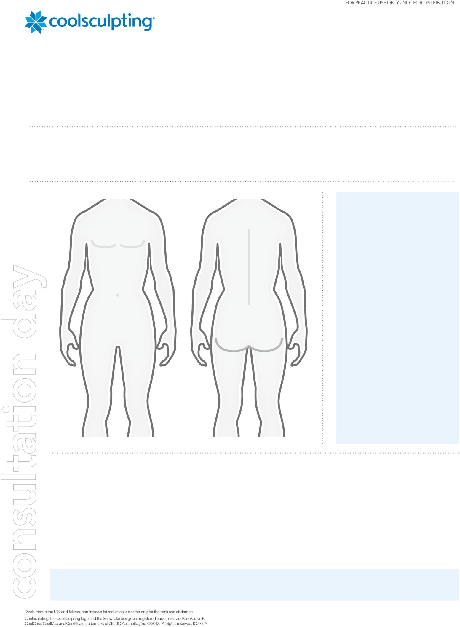
TREATMENT CONSULTATION FORM

Patient Name: Date:

Consultation led by: Gender: M / F Weight

Has your patient had other aesthetic procedures for the body?

How did your patient hear about CoolSculpting?

TREATMENT PLAN

CoolCurve+ (or eZ App 6.2):

CoolCore (eZ App 6.3):

CoolFit:

CoolMax (eZ App 8):

Total:

PRICING

Treatment price:

Discount:

Total:

Savings:

Notes:

Patient Signature: Date:

